Career Cruising Assessment Instructions
Go to: https://public.careercruising.com/en/
Registration Directions:
- Enter User name and password:
username: swic Password: careers Then select: login

- Click on and on the right select “Create My Plan” 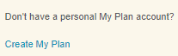This will take you to the Create My Plan Account page where you will register
- Complete the information and at the bottom of the page select . After entering your username, click on Check Availability on the right. Be sure to write down your Username and Password in order to log in to your account again.

- On the “Terms and Conditions” page check the box and click submit.

- Select the “Assessments” Tab at the top of the screen.

- Select “Start Matchmaker”.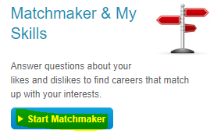

- At the bottom of the “Matchmaker” page, create a name for the session, and then select “Start Now”.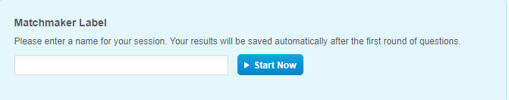

- Leave all levels of educations checked and click “Next”.

- Begin Matchmaker Questions. When answering the questions, do not choose the option “Does Not Matter”. This assessment needs to determine your preferences. Click on the box to select your choice.

- Once you have completed the first set of questions, in the left pane, go to “Improve My Results” and select “Answer More Questions”. You will do this a total of 2 times.

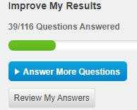
- Once you have completed all 116 of the questions for the Matchmaker Assessment, you will then complete the “My Skills” Assessment. Under the “Improve My Results” portion in the left pane, you will find “My “Skills”. Click on “Start My Skills” to begin the assessment.
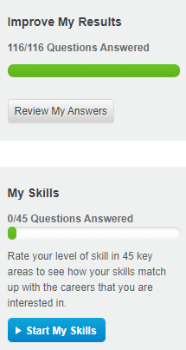
- Once you have completed the “My Skills” portion, your results will appear under the “Career of Interest Rank” section. Click on the career title highlighted in blue to research a career.
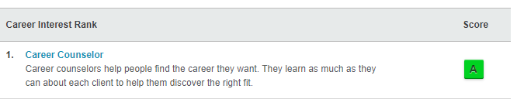
- In the left pane, you will find a “At A Glance” section for your selected career. Click on the blue links in the “At A Glance” section to find out more information about your selected career.
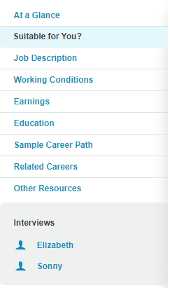
- Your information is saved and you may log in to see your results at any time. Complete step 1 and click “Login” to my plan and enter Username and Password.

