
Police Academy
2500 Carlyle Avenue • Belleville, IL 62221-5899
800-222-5131, ext. 5396 • (618) 235-2700, ext. 5396 • Fax (618) 236-1094
E-mail: Van.Muschler@swic.edu

Dear Deputy or Officer:

Start Date: March 25, 2021
Time: Arrive by 7:45am

LODGING AND MEALS
Lodging for the Police Academy is at the Candlewood Suites in O’Fallon, Illinois. The rate we receive is for double rooms, so in most cases you will have a roommate. If you make other arrangements, the housing cost may not be reimbursed by the Training Board. All rooms will be non-smoking. No changes can be made to room assignments without the prior approval of the Police Academy. The academy staff will automatically be making the room reservations for police and sheriff departments who choose it. During a normal academy week reservations will run from Sunday evening, with check in time after 3:00 pm, until Friday morning, with check out time 11:00 am. The meal plan includes 3 meals a day, breakfast, lunch, and dinner, but DOES NOT include snacks or drinks between meals.

DRESS CODE FOR THE POLICE ACADEMY – Male and Female
1. On the first day of class recruits should wear department issued uniform shirt, long or short sleeve, with collar, buttoned down the front. If a uniform is not available, recruits should wear a long sleeve dress shirt, with collar, buttoning all the way down the front and tie.
2. The following dress code will be adhered to throughout the training session:

Police Academy Uniform:
  - Grey Police Academy BLE Polo – Two (2) provided by the Police Academy.
  - Black 5.11 Tactical Pant (Mfg. #74251) or Black 5.11 Taclite Pro Pant (Mfg. #74273) – Two (2) recommended provided by department or student.
  - Department issued shoes or boots; black.
3. Officers staying "away from home" during the Academy should maintain and have available a set of "civilian" business attire clothing for special training and field trips.

COVID PROTOCOLS
All CDC protocols will be adhered to. All officers and deputies are required to bring their own face masks and nitrile gloves. Other cleaning supplies will be provided by the Academy.

PARKING
Parking is available on the south side of the campus in parking lot M5. You should park in the PARKING LANE FACING SIDEWALK DIVIDER BETWEEN LOT M5 and M4. See attached Belleville Campus Map.

FIRST DAY OF CLASS
Arrive early, be in the classroom by 7:45am. Class starts at 8:00am on March 25, 2021. Enter Door H. You will be directed to the classroom when you arrive.

ITEMS TO BE SUPPLIED BY OFFICERS AND/OR DEPARTMENT DURING THE BASIC TRAINING PROGRAM.

NOTE: Items 1-10 must be available on the first day of training. Academy schedules have been revised because of COVID. Firearms and Control Tactics are schedule the first two weeks of the Academy.

- 5.11 Tactical Pants, black. Two (2) recommended.
- Duty Belt.
- Duty Weapon Holster.
- Duty Weapon.
- 2 extra pistol magazines (total 3).
- Duty belt magazine case.
- Eye and ear protectors for firearms training.
- Duty belt handcuff case and handcuffs (with key).
- One police style flashlight for night training exercises.
- Body armor.
- Laptop – required. In the event of COVID-19 quarantine, distance learning will be required.
- Pocket size notebook
- Department squad car if possible should be provided for defensive driving and traffic stop procedures. (Recruits will be notified of the exact dates when they receive their schedule)
- Copies (electronic) of the following forms should be sent with the recruit officer.
  - Photo or electronic copy of department's Notice to Appear form.
  - 60 photocopies or electronic copy of department’s traffic citations.
  - 5 photocopies or electronic copy of department’s misdemeanor complaint form.
  - 1 photocopy or electronic copy of department written Miranda form.
  - 1 photocopy or electronic copy of department’s field sobriety report form.
  - 1 photocopy or electronic copy of department’s domestic violence report.
(Your department may not utilize all of the above-mentioned reports and forms. Bring with you the reports and forms your department does use.)
- PPE equipment - face masks and nitrile gloves. Academy will provide after 3rd day.

I am looking forward to meeting you. If you have any questions please call the Academy office (618) 235-2700, extension 5396.

Sincerely,

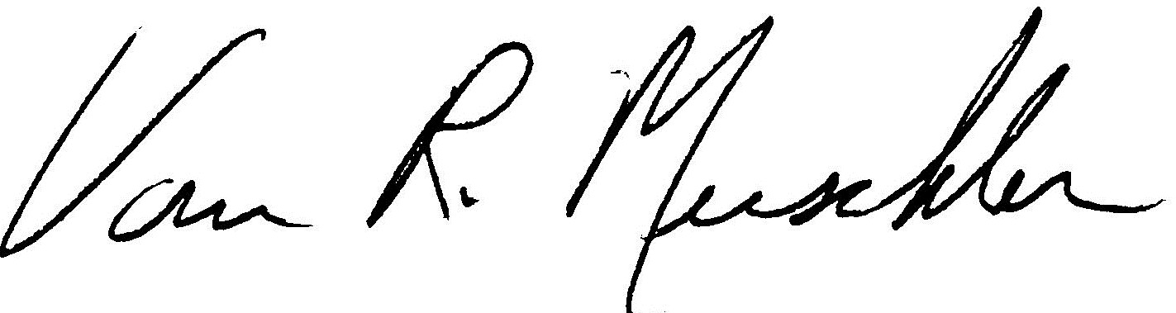

Van Muschler, Director
Southwestern Illinois Police Academy

SPECIAL NOTE: Any missed class sessions or part thereof, as a result of illness or injury will result in the recruit being docked the time missed and will be listed as hours absent. An officer will be considered absent even if present, when he/she is unable to perform or participate in the classes scheduled activities. Absences in excess of 56 hours will result in dismissal from the academy.


1332 Park Plaza Dr
O’Fallon, IL, 62269
Phone: (618) 622-9555
www.candlewoodsuites.com/Ofallon

Easily accessed from I 64 using exit 14 (US 50) or Exit 16 (Green Mount Road)



