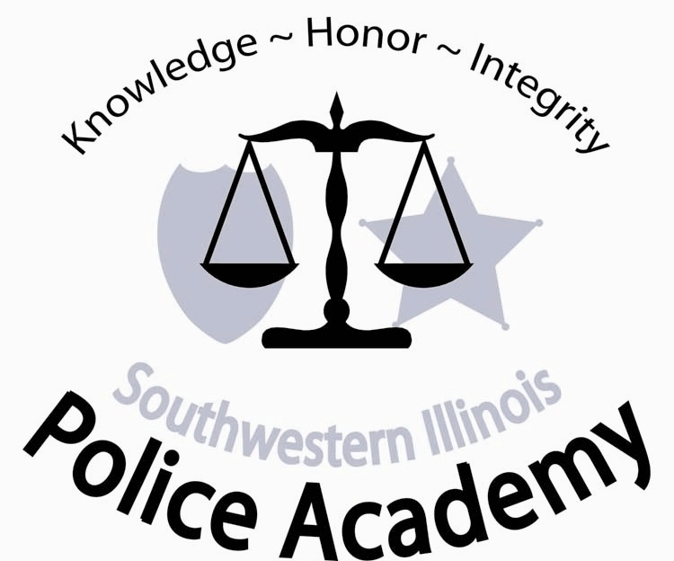
Police Academy
2500 Carlyle Avenue • Belleville, IL 62221-5899
800-222-5131, ext. 5396 • (618) 235-2700, ext. 5396 • Fax (618) 236-1094
E-mail: Van.Muschler@swic.edu

Dear Intern Officer:

DRESS CODE FOR THE POLICE ACADEMY

1. On the first day of class interns should wear a long sleeve dress shirt, with collar, buttoning all the way down the front and tie.

2. The following dress code will be adhered to throughout the training session:

Police Academy Uniform:
  - Grey Police Academy BLE Polo – Two (2) provided by the Police Academy.
  - Black 5.11 Tactical Pant (Mfg. #74251) or Black 5.11 Taclite Pro Pant (Mfg. #74273) – Two (2) recommended provided by department or student.
  - Shoes or boots; black.

3. Interns staying "away from home" during the academy should maintain and have available a set of "civilian" business attire clothing for special training and field trips.

PARKING

Parking is available on the south side of the campus in parking lot M5. You should park in the PARKING LANE FACING SIDEWALK DIVIDER BETWEEN LOT M5 and M4. See attached Belleville Campus Map.

If you have any questions please call the Academy office (618) 235-2700, extension 5396.

Sincerely,



Van Muschler, Director
Southwestern Illinois Police Academy

SPECIAL NOTE: Any missed class sessions or part thereof, as a result of illness or injury will result in the recruit being docked the time missed and will be listed as hours absent. An officer will be considered absent even if present, when he/she is unable to perform or participate in the classes scheduled activities. Absences in excess of 56 hours will result in dismissal from the academy.
ITEMS TO BE SUPPLIED BY INTERNS DURING THE BASIC TRAINING PROGRAM.

NOTE: Items 1-10 must be available on the first day of training. Academy schedules have been revised because of COVID. Firearms and Control Tactics are schedule the first two weeks of the Academy.

- 5.11 Tactical Pants, black. Two (2) recommended.
- Duty Belt.*
- Duty Weapon Holster.*
- Duty Weapon.*
- 2 extra pistol magazines (total 3).*
- Duty belt magazine case.*
- Eye and ear protectors for firearms training.
- Duty belt handcuff case and handcuffs (with key).*
- One police style flashlight for night training exercises.*
- Body armor.*
- Laptop – required. In the event of COVID-19 quarantine, distance learning will be required.
- Pocket size notebook
- PPE equipment - face masks and nitrile gloves. Academy will provide after 3rd day.

*Items will be supplied by the Police Academy for Interns.



