BASIC ARSON INVESTIGATOR

Dates:
Week 1 – March 28-April 1
Week 2 – April 4-April 8
Week 3 – April 25-April 29
Week 4 – May 2-May 6
Week 5 – May 16-May 20 (Firearms Range)
Students must attend all sessions
Length of Course: 200 Hours

Location:
Children’s Safety Village
4521 S. 11th St.
Springfield, IL 62703

Contact:
Captain Ryan Evans
Office: 217-789-2170
Cell: 217-414-6391
Email: ryan.evans@springfield.il.us

Length of Course:
200 Hours

Tuition:
$2283.00
Students are on their own for transportation, housing, and meals. Ammunition must be supplied by the student.

Questions:
Email Katie Carlton at Kathryn.Carlton@swic.edu

To Enroll Call:
Katie Carlton
1-866-942-7942 ext. 5396

More Information on our website:
www.swic.edu/pa
(Go to Menu tab, select Basic Arson Investigator Course)

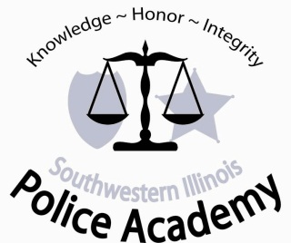
Basic Arson Investigator Class
Southwestern Illinois Police Academy

PLEASE POST AND PASS ALONG TO OTHER FIRE DEPARTMENTS!!!!!
The Southwestern Illinois Police Academy will be presenting the 200-hour Basic Arson Investigator Class beginning March 28, 2022.

This 5-week course for fire personnel is presented over 2 months and includes the 40-hour Mandatory Firearms Certification.

The course will be held at the Children’s Safety Village 4521 S. 11th St. Springfield, IL 62703.

Upon successful completion of the course, the attendee may submit for certification to the Office of the State Fire Marshal as an Arson Investigator.

Attendees may pay the tuition fee personally, but must be enrolled by the training officer or other command officer from their agency and meet the following requirements.

To attend this course, enrollees must meet the following prerequisites (Section 141.336):

- Employed by a local governmental agency or the Office.

- Successful completion of the Fire Investigator Course (see Section 141.334).

- Submit a letter of approval from their Fire Chief to attend the course and acknowledging that the attendee will be attending firearms training.
Certification of an Arson Investigator does not automatically qualify one to carry a firearm. For questions regarding this issue, contact your jurisdiction’s legal advisor.
Southwestern Illinois Police Academy will verify all enrollee’s certifications and employment through the Illinois State Fire Marshal’s office prior to the beginning of the course.

Students must be approved by Illinois State Fire Marshal’s Office to attend this course.

