- Integrity
- Teamwork
- Service
- Leadership
Swansea Police Department
Chief Matthew T. Blomberg

1400 North Illinois Street
Swansea, IL 62226
618-233-8114
Swanseap@SwanseaIL.org

The Swansea Illinois Police Department is seeking candidates to test for our Eligibility List for the position of probationary patrol officer. The list is viable for openings for 2 years from the date posted. The current collective bargaining agreement pay scale for probationary patrol officer is:

Starting salary of $60,278.40 plus great benefits. After probation:
$84,852.39

Interested candidates must submit a current resumé to swanseap@swanseail.org by March 3rd, 2023 @ 5 pm.

A candidate pool will be established from qualified applicants who submit the required information and background materials through the Swansea Police Department hiring portal. Resumés must be sent to the above email address by the specified date/time to receive the requisite link for document submission.

For a complete list of all required qualifications, please see below or visit the official Village website at www.SwanseaIL.org. Written and physical fitness (POWER) testing will take place at the SWIC Police Academy located at 2300 W. Main Street, Belleville, IL 62220 on Saturday, March 11th, 2023. The link to sign up for the fitness test is: https://www.swic.edu/academics/career-certificates/homeland-security/southwestern-illinois-police-academy/power-test-card/

The Swansea Police Department bases its hiring practices on merit, experience, education, and other qualifications applied to all applicants and in accordance with the principles of equal employment opportunity and as required by applicable federal, state, and local law.
Why become a Swansea Police Officer?

We have an amazing community where citizens truly appreciate their police officers! Numerous programs fuel the generous support from our community including Police Citizens Academy, Youth Academy, School Resource Officer, multiple community events, holiday programs, Bike Patrol Officers and much more. We are a very engaging and professional law enforcement agency priding ourselves on our proactive criminal patrols and community interactions.

- Great pay! START OUT AT: $60,278.40 plus great benefits. After probation: $84,852.39
- Many opportunities: SWAT, Detectives, Undercover Drug Tactical Unit, Police K-9, SRO, Bike Patrol, UTV Patrol, IDOT Traffic Grants, Major Case Squad of Greater St. Louis, Crime Scene Processing, Specialized Cybercrime Training, and Computer Voice Stress Analyzer!
- 12-hour shifts with every other weekend off (Fri/Sat/Sun)!
- Can volunteer for additional traffic grants for OT salary!
- Additional holiday pay!
- Additional education bonus!
- Education Tuition Reimbursement!
- Excellent health, vision, and dental insurance!
- Additional longevity bonus!
- Potential for OT or double compensatory time!
- Vacation, comp and personal time off!
- Modern equipment and uniforms!
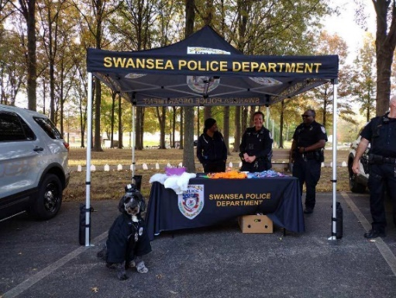
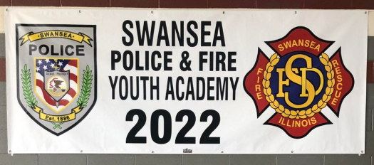

Minimum Qualifications for Candidates
Applicants must meet the following qualifications at the time of application:
- A completed application must be submitted to the Swansea Police Board of Police Commissioners through our hiring portal.
- U.S. citizen. - 21 years old. - Educational level at a minimum of an Associate’s Degree in Criminal Justice (or related field) or have completed 60 hours towards a Bachelor’s Degree in any field. Certain military service can exempt you from college. - Valid driver’s license. - Comply with all requirements of the position and have the ability to pass all examinations and training requirements.
- Applicant must have the ability to furnish upon request a copy of the following: a resumé, professional license, training certificates, documents work experience, birth certificate, high school diploma or GED certificate, transcripts of higher education, military service board and discharge papers (DD-214), employee evaluations, and any other employment related materials requested or required.
Come make a difference for a great department with fantastic community support!
Posted January 5, 2023

