SUCCESS CENTER: College Note-Taking — Overview
Note-taking helps you remember information from lectures or reading.
Go to all classes.

Write date, topic, and chapter on top of your notes.

Watch for signals of importance:
- Material on the board
- Definitions
- Repeated information
- Does the instructor glance at his notes to make a point?
Write instructor’s examples in your notes and label as EX.

Keep an open mind and resist reacting to emotional words.

Evaluate later.
Note-taking Tips
Write - Don’t Type
The present research suggests that using only laptops, rather than paper and pencil, to take notes results in lower comprehension and recall of the material. Writing notes by hand helps you reframe the information in your own words.

- Sit close to the instructor to hear better and stay alert. Taking notes helps you concentrate.

- Observe with an open and positive mindset. Refocus when your mind wanders.
- Mark in your notebook anything the instructor says is important or that will be on a test.

- Record: Write or draw images by hand.

- Use abbreviations and symbols (arrows/lines to show connections, < >, =, { }, *, ?, !!! to show relationships or significance)
- Draw a box around grouped information.
- Think about what you’re hearing and write ideas in your own words. Note any questions you will ask later.
- Be brief. List key words and main ideas from the lecture, not every detail. If your instructor is referring to the textbook, write down page numbers in your notes.
- Write on only one side of the page so you can add information later and/or write test questions on the blank side.

- Adjust note-taking based on the material. For some classes, your notes may be mostly pictures and labels.

- Cornell Note-taking System - a question column and a notes column (see our Success Center hand-out)
- Outlining – use numbers or bullets to help you organize information by importance
- Make a Chart – to simplify and organize information

Terms | Key Ideas - Definition | Significant Figures
Sociocultural | Focuses on relationship between social behavior and culture. Normal & abnormal behavior is defined by family, social group, and culture. | Vygotsky, Darley,  Latane’
Cognitive

- Mind Mapping - may contain pictures, boxes, lists, and sequences to show relationships
- Combination – Using the note-taking system that fits the information.

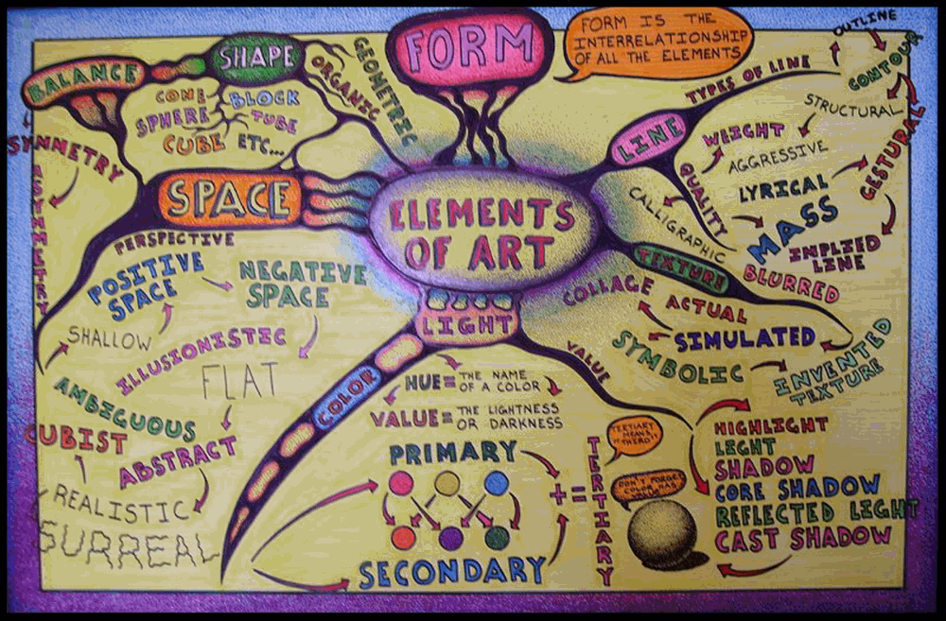
Sources: “Elements of Art mind-map.” Accessed 9 Jul. 2017. francinemassue.weebly.com/examples-of-mind-maps.html
Ellis, Dave. Becoming a Master Student. Houghton Mifflin, 2006.
Mueller, Pam A., and Oppenheimer, Daniel M. “The Pen is Mightier than the Keyboard: Advantages of Longhand over Laptop Note Taking.” Sage Journals Psychological Science 23 April 2014. Web 14 Jun, 2017. journals.sagepub.com/doi/abs/10.1177/0956797614524581
“Note Taking Tips.” Online image. Web 13 Jun 2017. www.slideshare.net/06021954/note-taking-and-study-techniques-for-highly-effective
“Taking Notes.” Center for Teaching and Learning Stanford University. Web 15 Jun 2017. web.stanford.edu/dept/CTL/Student/studyskills/taking_notes.pdf

