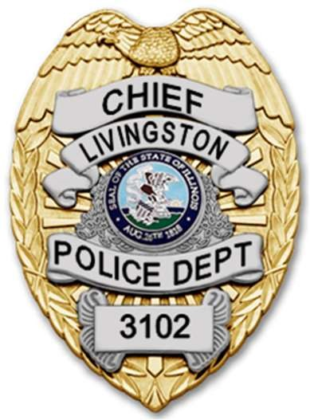 | Village of Livingston, Illinois  Police Department  Matthew R. Sinnokrak  Chief of Police  601 Livingston Ave  Livingston, Illinois 62058  msinnokrak@villageoflivingston.us  Department (618) 637-2300 Fax: (618) 637-2007 | 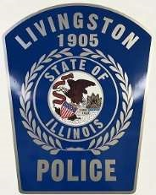

Are you interested in a career in law enforcement? The Livingston Police Department is looking for good individuals to join our force as part-time police officers. Below are our hiring standards:
Any person employed as a police officer must meet the following standards:
- Be of good moral character, of temperate habits, of sound health, and physically and mentally able to perform assigned duties.
- Be at least twenty-one (21) years of age.
- Possess a high school diploma or GED certificate.
- Possess a valid State of Illinois driver’s license.
- Possess no prior felony convictions.
- Any individual who has served in the U.S. military must have been honorably discharged.
- Previous law enforcement experience is helpful. Applicant must have completed at least the ILLINOIS Part-Time Law Enforcement Academy.
- Applicants will be required to complete the written application process, have an oral interview, and pass a background check.
Position is PART-TIME (could lead to full time). Hours are variable between Chief and Officer availability (8HR/10HR/12HR, week days/weekends, day/mid/night shifts). No weekly minimum, but we ask for at least one to two shifts a month to maintain status.
Current rate of pay is $20.50/hour.
Interested applicants can pick up an application at Village Hall (601 Livingston Ave, Livingston, Illinois 62058, Madison County, during office hours or may send a request for application to:
livingstonpd62058@gmail.com .

