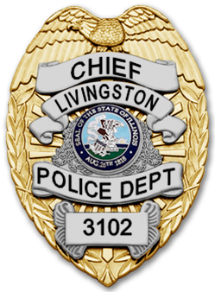
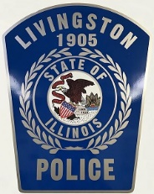
Village of Livingston, Illinois
Police Department
Matthew R. Sinnokrak
Chief of Police
601 Livingston Ave
Livingston, Illinois 62058
msinnokrak@villageoflivingston.us
Department (618) 637-2300 Fax: (618) 637-2007

ADMINISTRATOR/CHIEF: PART TIME – FULL TIME
Any person employed as a Chief/Assistant Chief must meet the following standards:
(1) Be of good moral character, of temperate habits, of sound health, and physically and mentally able to perform assigned duties.
(2) Applicants should have at least 5 years of service in law enforcement.
(3) Possess a high school diploma or GED certificate.
(4) Possess a valid State of Illinois driver’s license.
(5) Possess no prior felony convictions.
(6) Any individual who has served in the U.S. military must have been honorably discharged.
(7) Previous law enforcement experience is helpful. Applicant must have completed at least the ILLINOIS Part-Time Law Enforcement Academy.
(8) Applicants will be required to complete the written application process, have an oral interview, and pass a background check.
Position available would be 20-40 hours a week (Part time – Full time). Pay and hours negotiable with Village Board.

Interested applicants can pick up an application at Village Hall (601 Livingston Ave, Livingston, Illinois 62058, Madison County, during office hours or may send a request for application to: livingstonpd62058@gmail.com .

