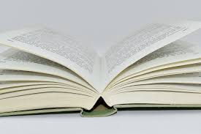
Face it, there’s more reading in college than in high school – and you need to actually do it!
Fortunately, there are strategies that can help you become a more efficient reader.

Planning for College Reading

Success
center
- Location: Choose a place that helps you focus. Do you need background noise or the silence of a library? (Pro Tip: Your bed is not a productive place to read or complete assignments.)

- Plan for completing reading assignments over several short periods each day (15-30 minutes). Take breaks to move around. Avoid long reading sessions.
REMEMBER:

You are expected to read the text and understand it on your own. But if you have difficulty, seek help from your instructor, the Success Center, or a classmate.

Complete reading before class so that you can understand lectures and activities.

- Mindset: Be actively engaged with what you read.
- Think of reading as a puzzle to solve.
- Download and/or print readings posted on Blackboard beforehand to avoid last minute technology problems if you prefer a hard copy.
- Decide how you will take notes.

- Lists, concept maps, outlines, and flashcards are options.
- The Success Center can provide note-taking strategies for all subjects.
- Eliminate distractions: Turn off all screens and technology alerts.
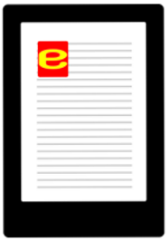
BEFORE YOU READ:

Get to know your digital textbook. Does it focus on a specific reading, or can the reader skip and scan easily? Can you bookmark pages? Can you save your progress? If you follow a hyperlink, does it open a new window? Practice switching between pages and sections in your online textbook.
Use these strategies with both physical and digital texts.
- Survey the digital or hard copy textbook to see how it is organized. Start with the table of contents. What information is presented? Is there a glossary of terms?
- Scan the pages and for headings, key words or sentences to see what is in the section.
- Re-read questions provided by your instructor or those in the textbook; read the section or chapter summaries, and bold vocabulary words to identify the key points.
- Imagine you will have an exam over the assigned reading during the next class in order to activate deeper levels of learning once you begin reading.

Sources: eReader jpg. Public Domain.
“Important Points about College Reading.” www.slideshare.net/navin_sosimple/reading-skills-15773917. Accessed 22 Jun, 2022.
“Reading College Textbooks – Finding Focus.” Student Success Center University of Southern Maine, usm.maine.edu/sites/default/files/learningcommons/07.Reading-College-Textbooks.pdf. Accessed 22 Jun, 2022.

“Reading Textbooks Effectively.” The University of North Carolina Chapel Hill https://learningcenter.unc.edu/tips-and-tools/reading-textbooks-effectively/. Accessed 22 June 2022.

