Success

center
Set a Purpose for Textbook Reading
You must read differently depending on what you want to get out of an assigned reading. The purpose includes what the instructor wants you to learn or understand from the reading.
Reading for different purposes requires different approaches.

PREPARE: TYPE OF TEXT | TOOLS: MINDSET
Consider what type of text you are to read.  Common examples include:  - Opinion; Argument; Persuasion  - Narrative (story, connected events)  - Description or Explanation  - Compare & Contrast; Cause & Effect | It’s Like Birdwatching…  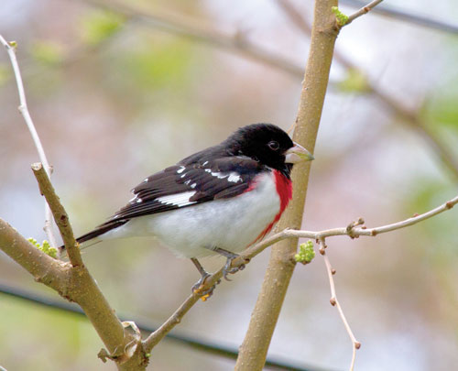  Say you’re going on a hike. You can choose to look for a specific songbird while you’re out – the rose breasted grosbeak. It doesn’t mean you can’t enjoy your hike or that you ignore other birds. But knowing that you are looking for a specific bird can make the hike more meaningful.
STRATEGIES FOR DIFFERENT READING PURPOSES
- Is this information to memorize? | Make flashcards and memorize as you read.
- Are you expected to explain or summarize the information? | Summarize each paragraph or section before moving on.
- Do you need to evaluate or respond to an argument? | Locate the writer’s main idea and the evidence and examples that support the claim.
- Will you need to use or apply the information in another situation? | Visualize when and how this information will be useful.
- Does the reading have background information such as the sequence of events? | List key points and/or causes and effects leading up to the event as well as the results.
- Is the reading assignment an example of a type of writing you will write? (i.e., a rhetorical analysis, a case study, etc.) | Read to discover how the writer introduces the topic and thesis statement. How is the information organized? Does each paragraph focus on one key point?

Once You Set a Purpose for Textbook Reading...

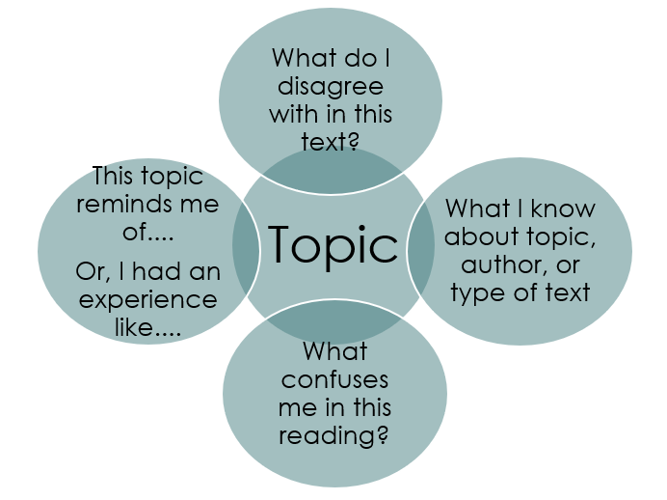
A college text may require that you read carefully, slowly, and deliberately. You will probably need to look up confusing words and reread key passages to understand them fully.

As you determine
why you are reading, and
what you want to learn, also think about
what you already know and
how it is connected to the reading.

Additional College Reading Tips
Stay focused on your reading purpose with these tips:
- When reading your assignment online or on a device, close other windows and programs. People are not able to multitask as it turns out. So, reduce distractions.
- Turn subtitles into questions: By making section headers into questions, that can help you find the answers.
- Open Narrator in Windows to read any on-screen text aloud.

Two ways to start and stop Narrator in Windows 10 and 11
- Press the Windows logo key + Ctrl + Enter together to start Narrator. Press these keys again to stop Narrator. (On older versions of Windows, the command was the Windows logo key + Enter.) OR
- Press the Windows logo key + Ctrl + N to open Narrator settings, and then turn on the toggle under Use Narrator.
- To turn scan mode on and off, press Narrator + Spacebar. (Both the Caps lock and Insert keys serve as your Narrator key by default.)
For more information on how to use Narrator visit: https://support.microsoft.com/en-us/windows/complete-guide-to-narrator-e4397a0d-ef4f-b386-d8ae-c172f109bdb1

Sources

“10 Strategies to Improve Your Reading Comprehension for College.” Purdue University Global 25 Aug 2020. https://www.purdueglobal.edu/blog/general-education/improve-reading-comprehension-college/. Accessed 20 Jul 2020
Linderholm, Tracy. “Reading with Purpose.” Journal of College Reading and Learning, 36 (2), Spring 2006, files.eric.ed.gov/fulltext/EJ742216.pdf. Accessed 19 Jul 2022.

Rose-breasted grosbeak. Illinois Natural History Survey, 2017. wwx.inhs.illinois.edu/research/biosurveys/birds. Accessed 6 Jul. 2017.

Sullivan, Patrick. “An Open Letter to High School Students about Reading.” American Association of University Professors, www.aaup.org/article/open-letter-high-school-students-about-reading#.WV1G54TytEZ. Accessed 10 Jul 2022.

