BASIC ARSON INVESTIGATOR

Dates:
Week 1 – September 25- September 29
Week 2 – October 2- October 6
Week 3 – October 16- October 20
Week 4 – October 23- October 27
Week 5 – November 6- November 10
Students must attend all sessions
Length of Course: 200 Hours

Location:
SWIC Police Academy
2300 W. Main St..
Belleville, IL 62226

Length of Course:
200 Hours

Tuition:
$2283.00
Includes housing and meals. Students are responsible for their own transportation and ammunition must be supplied by the student.

Questions or to Enroll Call:
Email Katie Carlton at Kathryn.Carlton@swic.edu
1-618-222-5396

More Information on our website:
www.swic.edu/pa
(Go to Section Menu, select Basic Arson Investigator Course)

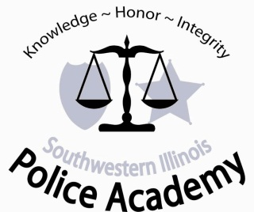
Basic Arson Investigator Class
Southwestern Illinois Police Academy

PLEASE POST AND PASS ALONG TO OTHER FIRE DEPARTMENTS!!!!!
The Southwestern Illinois Police Academy will be presenting the 200-hour Basic Arson Investigator Class beginning September 25, 2023.

This 5-week course for fire personnel is presented over 2 months and includes the 40-hour Mandatory Firearms Certification.

The course will be held at the SWIC Police Academy, 2300 W. Main St., Belleville, IL 62226.

Upon successful completion of the course, the attendee may submit for certification to the Office of the State Fire Marshal as an Arson Investigator.

Attendees may pay the tuition fee personally, but must be enrolled by the training officer or other command officer from their agency and meet the following requirements.

To attend this course, enrollees must meet the following prerequisites (Section 141.336):

- Employed by a local governmental agency or the Office.

- Successful completion of the Fire Investigator Course (see Section 141.334).

- Submit a letter of approval from their Fire Chief to attend the course and acknowledging that the attendee will be attending firearms training.
Certification of an Arson Investigator does not automatically qualify one to carry a firearm. For questions regarding this issue, contact your jurisdiction’s legal advisor.
Southwestern Illinois Police Academy will verify all enrollee’s certifications and employment through the Illinois State Fire Marshal’s office prior to the beginning of the course.

Students must be approved by Illinois State Fire Marshal’s Office to attend this course.

