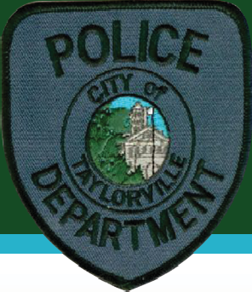
Taylorville
Police Dept.
Lateral Hires

Competitive Salary

The City of Taylorville is looking for lateral transfers.
The City of Taylorville offers a competitive pay and benefits package, including generous paid time off.
- 12- hour shifts
- Take home police vehicles live in city limits
- Own Dispatch Center
- ERT/Community Action Team
- Great working environment
Sworn Officers: 21 Population: 11,500

Minimum requirements:
  - State of Illinois certification or waiver by the Illinois Law Enforcement Training and Standards Board with no more than forty (40) hours of training required by that Board for recertification, if necessary.
  - Must be a legal resident of the United States.
  - Individuals must be at least 21 years old and under 65.
  - Education – High School Diploma or equivalent.
  - Experience – Applicants must have been a full-time officer for two years with an agency certified by the Illinois Law Enforcement Training and Standard Board.
  - Valid IL Driver’s License, or the ability to obtain within 90 days of hire (if out of state).
  - Must agree to comply with all position requirements and pass all examinations and training requirements.
  - Ability to furnish, along with their application, a copy of the following: a resume; professional licenses; training certificates; documents confirming work experience; birth certificate; high school diploma or GED certificate; transcripts of higher learning and college diploma or, if necessary, educational waiver request; naval or military service board and discharge papers (DD214); employee evaluations; and any other employment-related material as requested or required.
  - Must be able to obtain a waiver from ILTSB.
Contact Information

City of Taylorville
108 W. Vine Street, Taylorville, IL 62568 • 217-824-2211
dwayne.wheeler@taylorvillepolice.com
Completed applications and documents must be submitted in person, by mail, or by email. To dwayne.wheeler@taylorvillepolice.com
Applications are Available at https://taylorville.net/police-dept/. Deadline: 1-21-2024 for immediate hires.
We will be accepting continuous applications.

