SUCCESS CENTER PRACTICE SHEET
ECONOMICS

DEMAND and SUPPLY

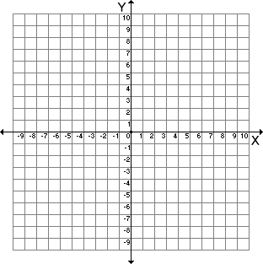
- Illustrate an example of the Law of Demand by showing an appropriate curve.

- Illustrate an example of the Law of Supply by showing an appropriate curve.

